Operations

ITRC Computer Center

ITRC Network Infrastructure, Support Infrastructure, and Operations G2G Report

**[](http://www.google.com/url?sa=i&rct=j&q=&esrc=s&source=images&cd=&cad=rja&uact=8&ved=0CAcQjRxqFQoTCKvS8r6GkMkCFQt-iAodcA0OSg&url=http://www.guamcc.edu/Runtime/articulation.aspx&psig=AFQjCNHTZsiECQCIY2A7hSEpWAZvE7JtOQ&ust=1447595196021376)**

DRAFT V-20151130

***SUMMARY***

***-2nd year of 24-7 WebAdviso has been carried out successfully***

***-Implementation and limited Pilot Live service has been successfully***

***to have more than 6000 Smartphones registered***

***-365 emails with mobile phone can provide a new low cost VOIP***

***-Smartphone has been upgraded to access Web Advisor service***

***-Enhancements of IT Infra have provided more than 500 connections***

***with some of the high-capacity rooms/labs***

***-The above achievements help support WASC Iinitiatives, President-***

***SVP & VPAF Initiatives.***

**Will be published on UOG ITRC Computer Center Website:**

[**http://www.uog.edu/student-services/computer-center/projects**](http://www.uog.edu/student-services/computer-center/projects)

# Table of Contents

**ITRC Needs ……………………………………………………………………………………………………………………**.2

**Network Infrastructure**

(Network Upgrade - 10G Backbone and 1G Connections)…………………………………..…..3

Campus Backbone *Map and Wireless Hotspots…………………………………………..………….4*

*Wireless Access Point Upgrades………………………………………………….…………………………5*

*Dorms’ Network and Wireless (Anticipated about 50 Access Point)*

*UOG Smart Device / Mobile Counts (Over 11000 with 51% of Smartphone)*

*CollegeNet Evaluations- Large Capacity Labs for Student/ Faculty Use…………..………6*

*VOIP – Skype for Business, Avaya………………………………………………………………………………7*

**Support Infrastructure**

*TVSS Information*………………………………………..……………………………………………………………..8

*UPS Information* ……….………………………………………….………………………………..………………….9

**Operations**

*Computer Center Lab Plans……………………….………………………………………………………………10*

Office 365 ……………………………………………………………………………………………………………….11

Help Desk…….……………………………………………………………………………………………………..……12

Quality Report………………………………………………………………………………………………………….13

**Ellucian** ……………………………………………………………………………………………………………………..…..14

**Written by Felix Mansapit**

**What are the needs of ITRC today?**

1. **CLEAN THE AIR DUCTS AS PROMISED SINCE LAST YEAR AFTER THE ELECTRICAL FIRE.** 
   * NOW W/THE ARRA CONSTRUCTION DUST POLLUTING THE DUCTS, WE HAVE EVEN MORE CONSTRUCTION DEBRIS IN THE DUCTS & CEILINGS.
2. **CORRECT/FIX/COMPLETE THE POWER BACKUP SYSTEMS:** 
   * TRANSFER SWITCHES (Generators & Internal for UPS)
   * UPS SENSITIVITY
   * COMPLETION OF 2ND UPS INSTALLATION & ELECTRICAL MODIFICATIONS.
3. **COMPLETE ALL OUTSTANDING ARRA RELATED ELECTRICAL MODIFICATIONS:**
   * CPU POWER OUTLETS & POWER CORDS TO BE CHANGED W/INTERLOCKING PLUGS
   * ALL PLUGS TO BE STANDARDIZED (BOTH 110V/220VV)
   * RE-ENERGIZE DEAD OUTLETS & CONNECT TO UPS-GENERATOR SUPORTED OUTLETS.
4. **REPAIR/CORRECT AIR DUCTS PROBLEMS:** THERE IS LITTLE OR NO AIR FLOW GOING TO ROOMS. UNCOMFORTABLE FOR STAFF & NOT GOOD FOR OUR EQUIPMENT.
   * TAPE LIBRARY
   * ELECTRICAL ROOM
   * DEVELOPMENT STAFF OFC.
5. **REPAIR ALL LEAKS IN TH CEILINGS THROUGHOUT THE BLDG.** **(REPLACE CEILING TILES)**
   * SPECIAL LAB
   * SUPPORT
   * HALLWAYS, ETC…
6. **REPLACE DOOR JAMBS THAT ARE INFESTED W/TERMITES**
   * REPAIR / REPLACE DOOR CLOSERS
7. **REPLACE EXTERIOR DOORS: RUSTED OUT (CAN BE HAZARDOUS)**
   * SPECIAL LAB
   * EMERGENCY EXIT (ON RFK SIDE)
   * CO2 ROOM

# Network Infrastructure

**Network Upgrade - 10G Backbone and 1G Connections**

Marked with red are buildings with 10GB backbone, and the rest are 1GB.

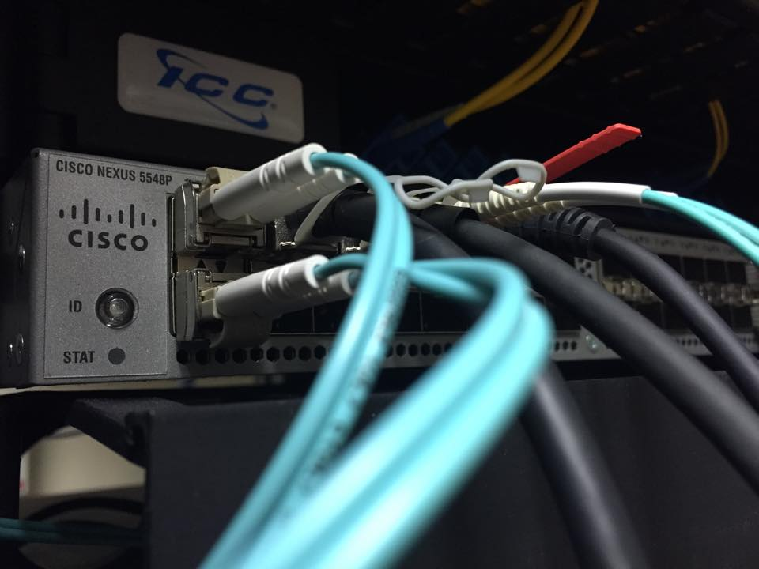

Cisco Nexus Switch –10GBPS containing 48 ports

|  |  |
| --- | --- |
| UOG Network migration to Nexus | |
| Building | **Date Completed** |
| BO | 3/1/2014 |
| CALS | 8/3/2013 |
| SC | 8/24/2014 |
| EC | 6/12/2013 |
| Lecture Hall | 2012 |
| HSS | 9/21/2014 |
| Student Center | 10/12/2014 |
| SOE | 9/21/2014 |
| FA | 2/1/2013 |
| SNHS | 10/19/2014 |
| LG | 11/11/2014 |
| FH | 11/16/2014 |
| Science Annex | 7/24/2015 |
| WHB | 8/3/2015  Cisco Catalyst 3560G: 48 Ethernet 10/100/1000 ports and 4 SFP-based Gigabit Ethernet ports |

**Outcome:** There are a total of 14 ready locations that are migrated to Gbps network. 3 switches capable of 10 Gbps(BO, LG, and FH), and the rest are 1 Gbps. See table above for more information.

BO, CALS, SC, EC, Lecture Hall, HSS, Student Center, SOE, FA, SNHS, LG, FH, Science Annex, and WHB buildings have been migrated to the Nexus. Major support departments located in Business Office, LG building, and Fieldhouse network are now running at 10GB capacity. The rest of the buildings have been migrated to run at 1GB capacity, and are in plans to be configured to 10 GB capacity. Buildings running 1GB capacity do not have switches capable of running 10GB throughput, and must be upgraded to a Cisco 10 GB switch. In addition, Fiber Optic lines running to buildings must be connected to 10GB SFP’s. Assessments of buildings must be performed prior to expanding throughput.

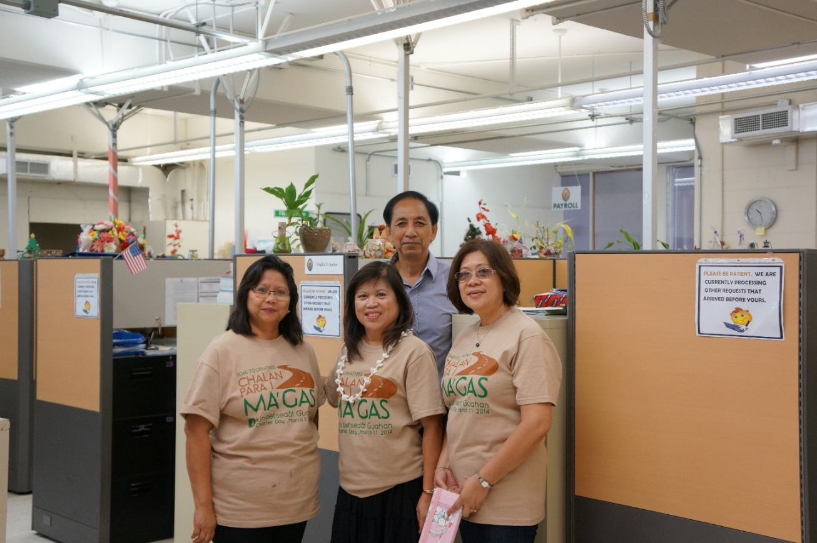

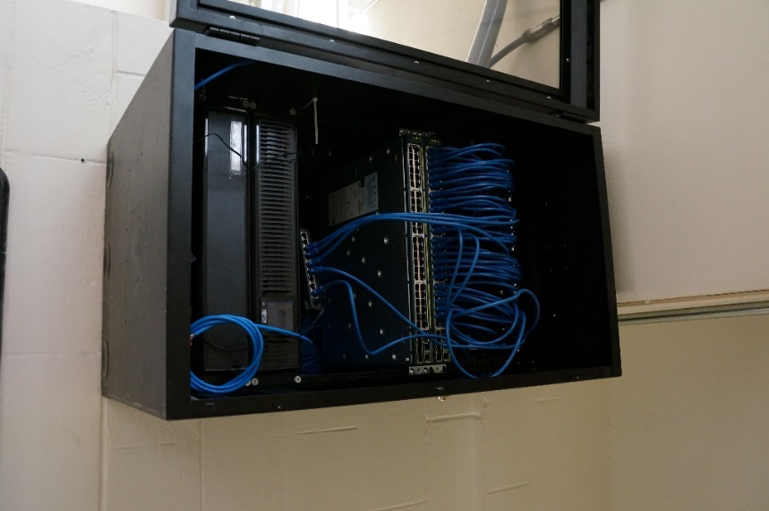

Business Office Gbps Switch

Business Office

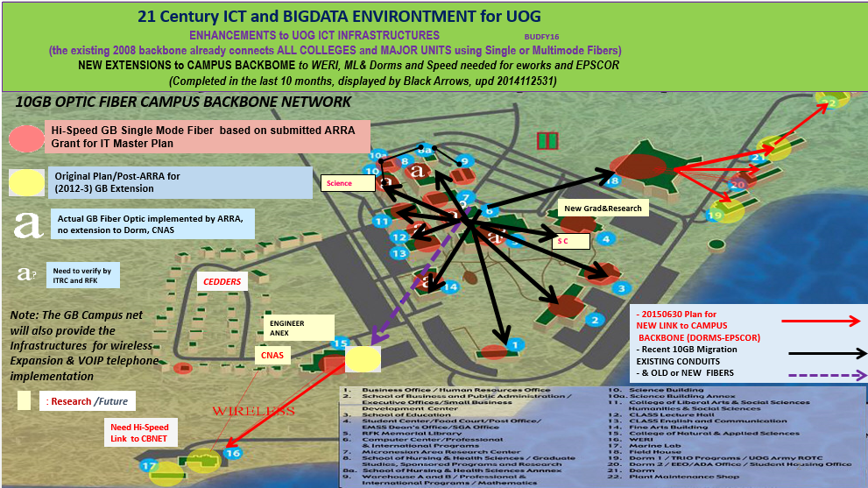

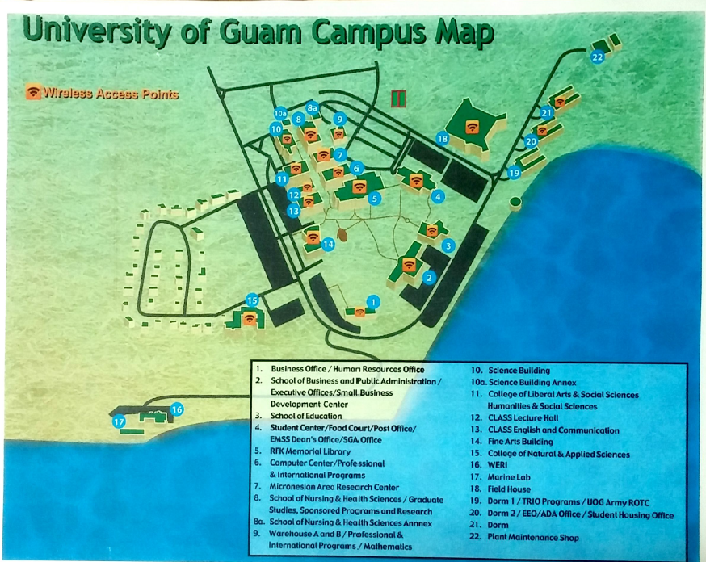

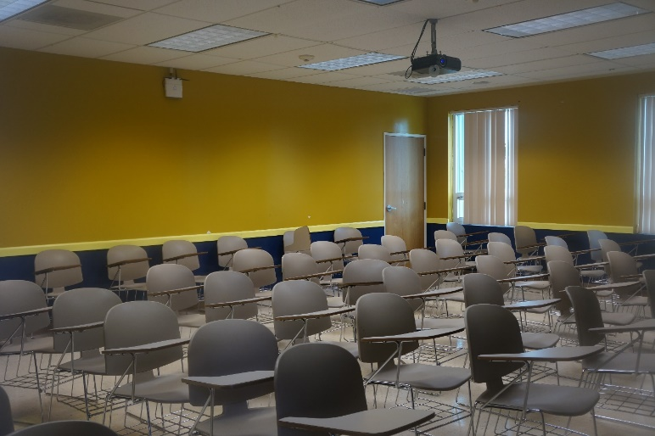**Network wireless access points upgrade**

**HSS CLASSROOM 106**

LIBRARY

|  |  |  |
| --- | --- | --- |
| UOG Wireless Access Point Upgrade | | |
| Location | **Number of Access Point** | **Date Completed** |
| BO | 1 | 3/4/2014 |
| CALS | 4 | 10/17/2013 |
| Computer Center | 5 | 6/28/2013 |
| ECC | 6 | 2/3/2014 |
| EMSS | 3 | Summer 2014 |
| FA | 3 | 2/28/2014 |
| FH | 5 | Summer 2014 |
| HRO | 1 | 5/5/2014 |
| HSS | 7 | 2/18/2014 |
| Lecture Hall | 1 | 7/22/2014 |
| LG | 13 | 2/24/2014 |
| MARC | 1 | Summer 2014 |
| MATH | 2 | 5/19/2014 |
| PIP | 1 | Summer 2014 |
| RFK | 10 | 9/30/2013 |
| Science Building | 3 | 7/30/2013 |
| Science Annex | 2 | 8/30/2015 |
| SNHS Annex | 2 | 6/3/2015 |
| SOE | 9 | 2/22/2014 |
| Total | 88 |  |

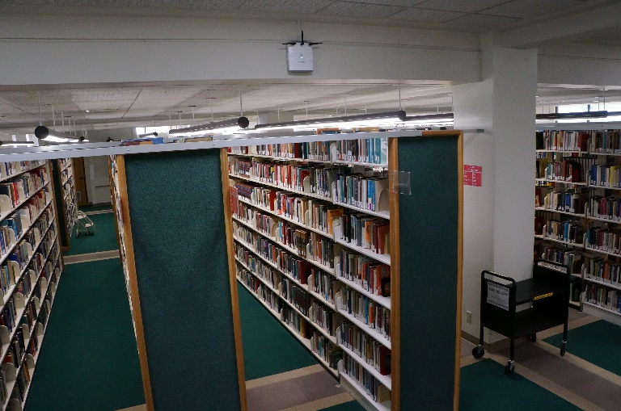

**Update:**

Overall total wireless access point at UOG is at 88 and are strategically installed in various locations of each building to propagate Wi-Fi signals for student use. There have been 2 AP’s installed during FY 2015. Above illustrations are few of our many locations in which an AP is installed.

|  |  |
| --- | --- |
| DORMS ACCESS POINTS | |
| Dorm 1 – 1st Floor | 10 |
| Dorm 1 – 2nd Floor | 0 |
| Dorm 2 – 1st Floor | 10 |
| Dorm 2 – 2nd Floor | 9 |
| Dorm 3 – 1st Floor | 10 |
| Dorm 3 – 2nd Floor | 9 |
| TOTAL | 48 |

**Future Plans:**

Dorm network is in the plans of having 48 access points installed at their location. 3 Switches and 48 access points have been configured in preparation to install the access points. At this time a bid to connect the Dorms to UOG network using Fiber optic cables is being processed and managed by Plant Management. Fiber optic cables will be connected to the field house, and upon completion ITRC is ready to install configured switches, and routers. In addition, Dorm plans to have at least 4 IT work areas/student lounge:

Dorm 1: 1 IT work areas/student lounge

Dorm 2: 2 IT work areas/student lounge

Dorm 3: 1 IT work areas/student lounge

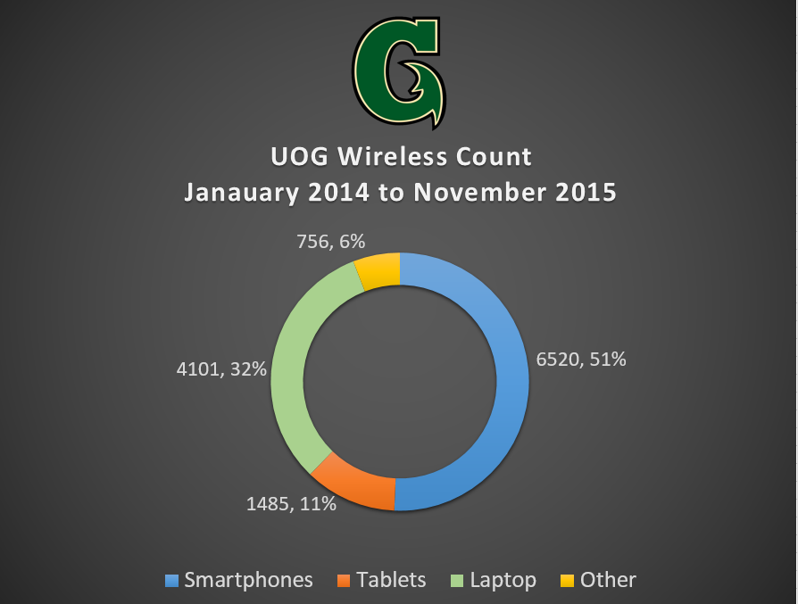**UOG Wireless Activation (Mac Filtering):**

From January 2014 to November 2015 smartphones are the most common device for wireless activation. Policy activation includes a limit per user of one cellphone, one tablet, and one laptop for wireless activation.

**College Net Evaluations: Large Capacity Labs for Student/Faculty Use**

SBPA Room 218 – Lab Capacity 21 Computers

SBPA Room 234 – Lab Capacity 25 Computers

SBPA Room 219 – Lab Capacity 25 Computers

SBPA Room 220 – Lab Capacity 24 Computers

CLASS: (HSS 111, 1st Floor) – Lab Capacity 20 Computers

CNAS: SNHS Science Annex – Lab Capacity 30 Computer  
SOE: SOE 108a and 108b- Lab Capacity 20 Computers

Computer Center: 107b – Lab Capacity 20 Computers

List consists of locations of large capacity labs for CollegeNet Faculty Evaluations by department. Students/ faculty may schedule with departments to reserve Computer Labs if available.

VOIP

[](https://www.google.com/url?sa=i&rct=j&q=&esrc=s&source=images&cd=&cad=rja&uact=8&ved=0CAcQjRxqFQoTCPn_itv6j8kCFcYyiAodAh8GDw&url=https://blogs.office.com/2015/03/18/skype-for-business-is-here-and-this-is-only-the-beginning/&psig=AFQjCNFfvTT6H3TbAmkie7AAfv8NyoiNgw&ust=1447592032638740)

[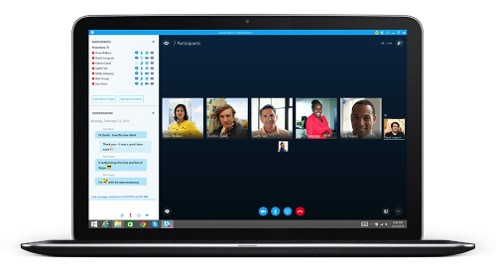](http://www.google.com/url?sa=i&rct=j&q=&esrc=s&source=images&cd=&cad=rja&uact=8&ved=0CAcQjRxqFQoTCJjapur7j8kCFY42iAodyf0EXw&url=http://www.skype.com/en/business/skype-for-business/&bvm=bv.107467506,d.cGU&psig=AFQjCNFskgLts2C_SfGkugjznM_caXGL7A&ust=1447592335049925) Skype for business is offered using Office 365 accounts. Users migrated to office 365 will have the opportunity to use video conference as an option for communication to host meetings, sessions, etc.

**Update:**

Enabled and tested Office365 VOIP using Microsoft Lync/Skype successfully between 3 in-cloud accounts. Testing of video conference is successful between 2 or more Office 365 users using 2 or more devices (Laptop, Cellphone, and Tablet). Currently researching financial and infrastructure feasibility.

Skype for Business on Laptop

[https://upload.wikimedia.org/wikipedia/commons/thumb/8/8b/Avaya_Logo.svg/220px-Avaya_Logo.svg.png](https://www.google.com/url?sa=i&rct=j&q=&esrc=s&source=images&cd=&cad=rja&uact=8&ved=0CAcQjRxqFQoTCPnLiPX6j8kCFVGjiAodR_MFiQ&url=https://en.wikipedia.org/wiki/Avaya&bvm=bv.107467506,d.cGU&psig=AFQjCNGQ7Mn9rHGtQF-wnlb3NRRKaj1igQ&ust=1447592088804072)

Process of testing Part 1 of 2 training have been conducted. Test AVAYA phone deployment will be performed on major support departments after training has been conducted. Awaiting GTA to schedule second training. The migration of multiple departments will be initiated once testing is successful, and approved by administration.

# Support Infrastructure

Power Anomaly Protection Equipment

In an effort to maintain & provide consistent network services, ITRC has installed ups systems with extended battery packs to support remote network sites throughout the campus. In addition to the added ups support, ITRC is currently working with Plant Maintenance to install building surge protection - tvss devices in each of the buildings.

The TVSS devices will protect network equipment, electrical and mechanical devices within the buildings.

Please see tables for latest updates on provided equipment.

**TVSS Locations** have been provided to listed departments. Below is a table illustrating TVSS installations around UOG.



**Summary Impact:**

Since equipment was provided there were no reports of damaged equipment from power anomalies during FY15. TVSS allows departments to protect not only network equipment but also all equipment connected to the same power source. TVSS serves as the first line of protection against power anomalies allowing clean a clean power source.

**UPS Locations**



**Summary Impact:**

Since equipment was provided there were no reports of damaged equipment from power anomalies during FY15. Network Equipment is responsive and working properly to provide efficient internet connection in perspective departments. With the capability of surge protection and battery backup the UPS is the second line that protects equipment from power anomalies.

# **Operations**

Phone, and email support are available 24/7, except on Government of Guam Holidays.

Please visit <http://www.uog.edu/student-services/computer-center/computer-center-home> for announcements.

As of 31 March 2014 WebAdvisor will be available 7 days a week except for the following maintenance windows:

M-Th: 8PM - 11PM

Friday: 8PM - 1AM

Saturday: 8PM - 11PM

Gov Guam Holidays- Closed

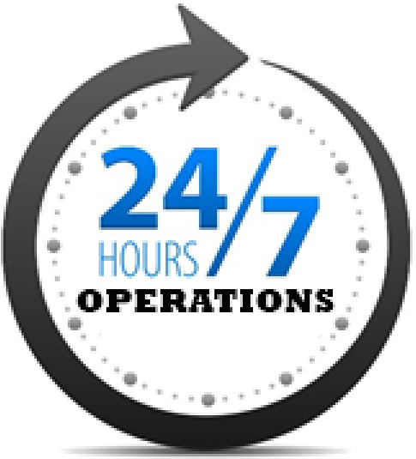

Operations have provided 24/7 support for over a year. We have experienced problems with UPS, power anomalies, and short staff, although with teamwork and proper management we are able to provide reliable support to students, faculty, and staff. 24/7 support and services are ongoing, and operations is committed to answer questions, assist users, and escalate requests to the proper channels.

Outcome:

ITRC provides 24/7 Webadvisor services successfully during FY15 despite of lacking supporting infrastructure.

**Computer Center Lab**

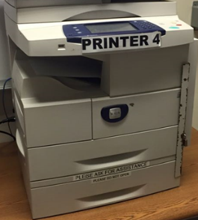

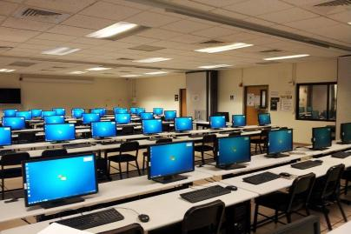

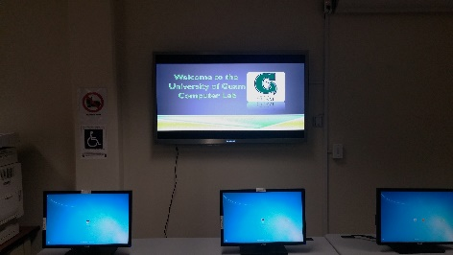

Hours of Operation

Monday to Friday: 8:00am to 9:00pm

Saturday: 9:00am to 3:00pm

Sunday/ Holidays: CLOSED

Intersession/Summer

Monday to Friday: 8:00am to 8:00pm

Saturday: 9:00am to 2:00pm

Sunday/ Holidays: CLOSED

A computer lab equipped with a network of mainframe, microcomputers, terminals, graphics devices & multimedia systems, software - including statistical analysis packages and compilers, and internet access is available for student and faculty use. Students are given the opportunity to scan, and print documents, and are able to activate their wireless devices at Computer Center.

**Future Plans:**

Computer Center plans to deploy Smart ID Card upcoming 2016. Smart Card ID is in the midst of testing, and will be used to better promote the Go Green movement. Once Smart Card ID is deployed users using the smart card will have their very own profile encrypted with a personalized pin. Computer Center will be limiting the number of print-outs per student per semester. Money saved on paper will be used to improve the network infrastructure of UOG.

[](https://www.google.com/url?sa=i&rct=j&q=&esrc=s&source=images&cd=&cad=rja&uact=8&ved=0CAcQjRxqFQoTCO-g_oC8j8kCFcqkiAodGrEL5A&url=https://www.uclan.ac.uk/students/study/it/office_365.php&psig=AFQjCNHTfnPs5sllvb82Ll713JsqaJt4uw&ust=1447575204825447)

**Features:**

* Office 365  provides online services that allows collaboration and easy information sharing
* Office 365 online services include basic word and data processing programs and other advanced cloud sharing services such as OneDrive.
* Office 365 provides 50 GB of mail storage, and 1 TB of OneDrive Cloud storage.
* Office 365 allows access to all its services with internet connection.
* Office 365 comes with the full office suite available to install for 5 local client machines for a variety of devices. (Pending administrative decision).
* Office 365 uses a shared organization directory that allows easy user communication and group coordination.

**Update:**

*Faculty & Staff*

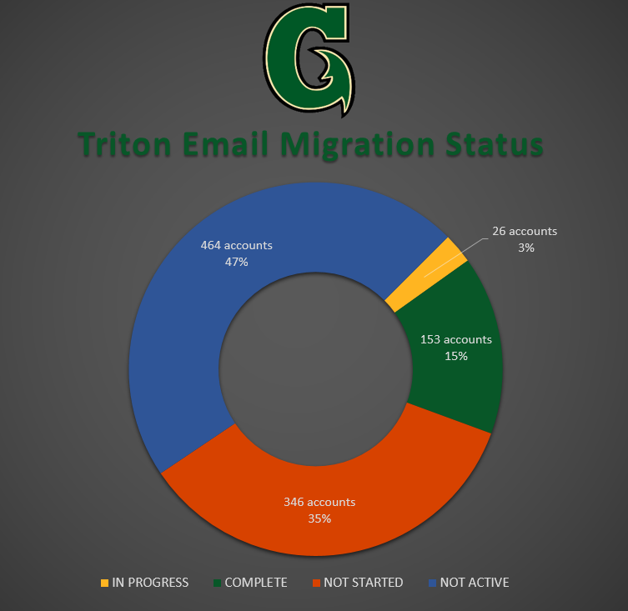Roughly 380 users are pending email migration. In the meantime, ITRC has made plans to be further proactive with the migration by contacting smaller departments to move forward with their migration.

*Student*

In-house testing of the Student email service is ongoing. Currently no issues have been encountered or reported and testing for the most part is being considered complete. However, due to a lack of manpower and staff availability concerns were brought up regarding the idea of migrating Faculty & Staff and Students simultaneously. The current plan is to complete Faculty & Staff and shift the manpower to Student migration.

**Help Desk**

[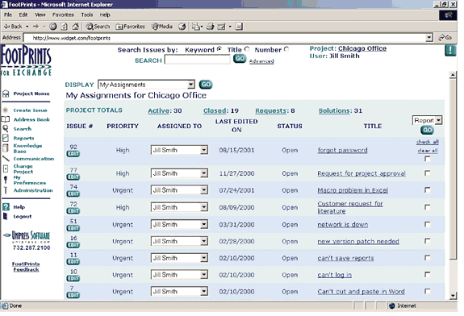](http://www.google.com/url?sa=i&rct=j&q=&esrc=s&source=images&cd=&cad=rja&uact=8&ved=0CAcQjRxqFQoTCLbGhob_j8kCFccsiAod868OLg&url=http://windowsitpro.com/systems-management/help-desk-software-22-apr-2002&bvm=bv.107467506,d.cGU&psig=AFQjCNEyKUDXNPUggiVHmfGRxT3wrgt-Sw&ust=1447593187289370)

By providing a reliable tracking system with an integrated quality control process the Footprints Helpdesk system allows the help desk team to properly provide quality services based on generated statistics.

**Future Plan:**

Updated Help Desk deployment is tentatively set for early 2016 for UOG intranet.

About Footprints:

* Improve efficiencies by simplifying and automating routine tasks.
* Improve satisfaction with an easy-to-use interface.
* Maintain compliance as you document, record, and centralize IT tasks.
* Create business value and reduce risk with better visibility into the IT environment.

[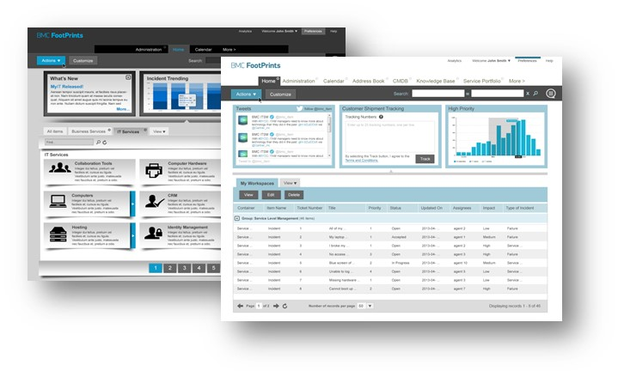](https://www.google.com/url?sa=i&rct=j&q=&esrc=s&source=images&cd=&cad=rja&uact=8&ved=0CAcQjRxqFQoTCNP7uq6AkMkCFUmUiAodz94HXw&url=https://communities.bmc.com/community/bmcdn/service_core/blog/2014/04/29/what-i-love-best-about-footprints-service-core-12-have-you-checked-it-out&psig=AFQjCNHpE6PsqeXL06XXcPnbI0a2-ppBMg&ust=1447593498116639)

Latest Version of BMC FootPrints

**Quality Report**

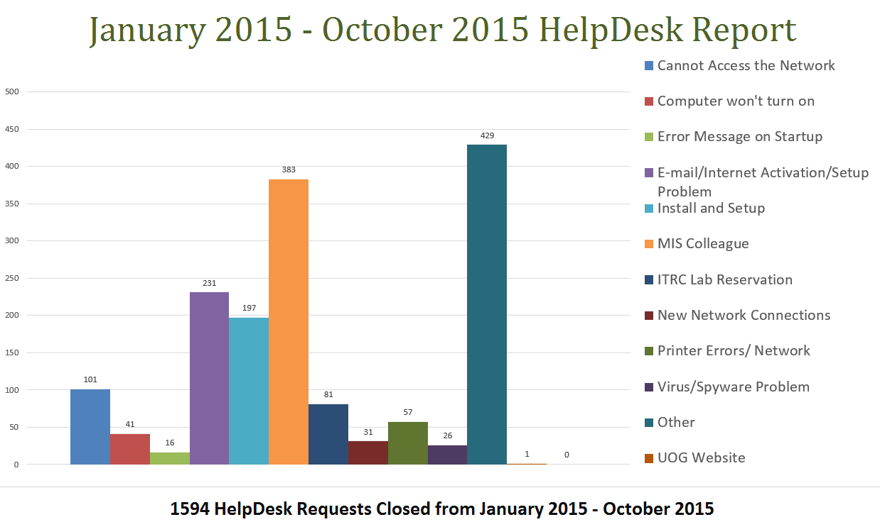

“Cannot Access the Network” has a count of 101 due it including requests such as:

* Being locked out of uog services-acct when several failed attempts of entering wrong password
* Activations for University services.
* Wi-fi acct. Activations for mobile devices.
* etc.

“Cannot Access the Network” is only 6% of the overall 1,594 Help Desk Requests.

This indicates that UOG’s network configuration and support is reliable based on statistical average.

Quality Control Process:

* A Monthly report is produced for Helpdesk Requests tickets that undergo a Quality Control check.
* Not all users are able to be reached back for the Quality Control but majority of users who are contacted report to be satisfied with the service they have received.
* The Quality Control process ensure that quality services is provided.

Outcome:

By performing monthly Quality Control checks on the services we are able monitor growths and improvements. For example the total number of requests performed in the two most recent quarters show a 47% increase in requests. Analyzing statistics allows us to make the best decisions to continue providing quality services. These services include Network solutions (Wireless and Local Area Connectivity), troubleshooting end user computing, providing guidance and training, and many more. ITRC/Computer Center is able to close an approximate average of 163 requests per month as of FY15.

## **University of Guam is awarded the Ellucian Mobile Grant**

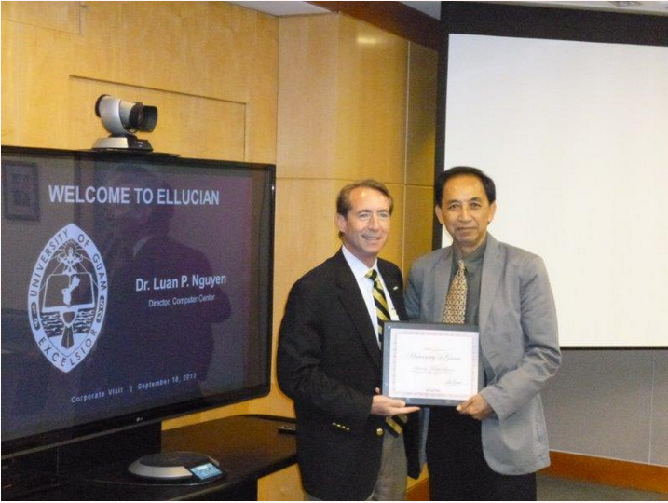

#### **Ellucian is the world leader in mobile**

Ellucian Mobile is a higher education mobile app that easily integrates with existing—and constantly evolving—IT platforms and strategies. Used by more than 900 colleges and universities around the globe, Ellucian Mobile is the most widely adopted mobile solution for higher education.

#### **Mobile Application**

The Univeristy of Guam Computer Center is upgrading and migrating our services to support a mobile app for our students and faculty. Our mobile application will be launched within the coming months.